**The complete Documentation of** **KEYWORDS SCRAPPER**

1. **Layout Implementation**
2. **Browser Modules Proxy-less**
3. **Website Path**
4. **Keywords Length**
5. **Scrap Count**
6. **Time Elapsed**
7. **Output Result**

**LAYOUT IMPLEMENTATION**

**In this the layout must be in a cmd that must contain with the scrapper name ( KEYWORDS SCRAPPER ) As we asume that the version of the tool must start with (V0.0.1)**

**In this scrapper name must be in design with the size of 48 the scrapper name must be at middle of the tool**

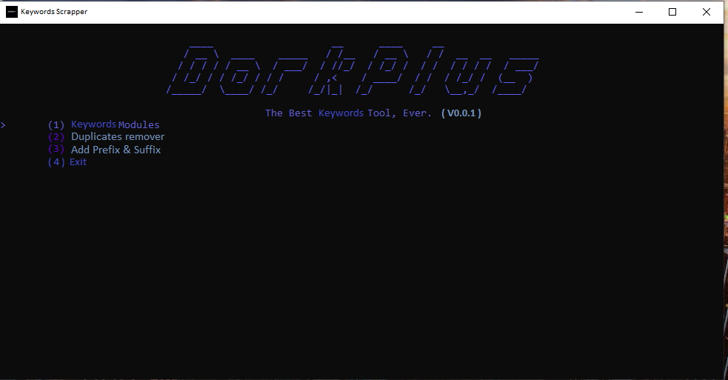

**Its just an example picture at the top there we can see dorkplus that u have to change it in to (KEYWORDS SCRAPPER)**

**Coming to second one there is duplicates remover if u can add the feature u can add or else leave it…**

**BROWSER MODULES PROXY-LESS**

**As soon as we click on the keywords modules the interface of the tool that must open with the browsers as shown at the bottom**

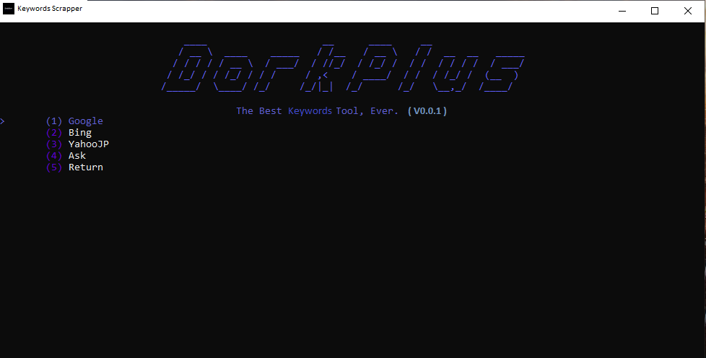

**As its shown in the figure the same interface should be on the tool……..**

**WEBSITE PATH**

**As we click on the web searcher on the tool there will be a options like google, ask…. so on if I click on google it should show the interface that image is given on the bottom where it should scrapes the keywords from that particular site**

**As for example:-https://www.netflix.com/in/browse/genre/839338**

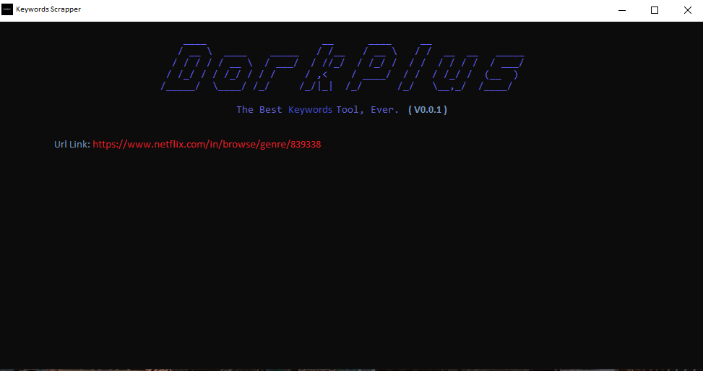

**As shown in the image at top the link we must place over there to scrap the keywords from the website……**

**KEYWORDS LENGTH**

**The length of the keywords must be 2 - 6 words only the keywords length must not less then that or more than that**

**For example the keywords should be like :-**

**Money heist series**

**Wednesday series**

**Don movie**

**Rana naidu web series on netflix**

**Sir movie**

**The night agent**

**As so on the keywords must be in the acuurate manner**

**SCRAP COUNT**

**Here it should show the scrap count of the keywords scrapped from the website as shown in the bottom image**

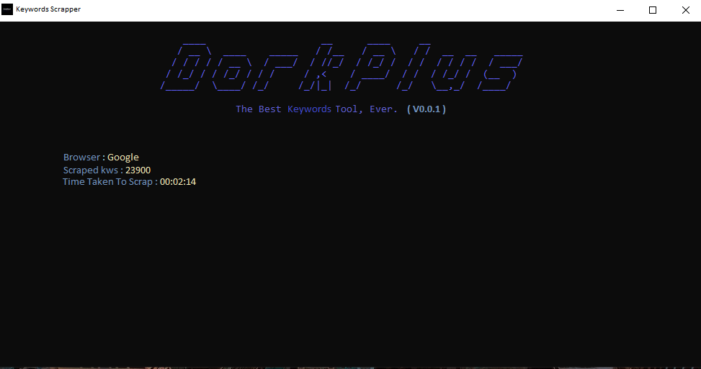

**As we can see there the time taken to scrap button should be added on tool to know how much time is taken to scrap the kws……………**

**OutPut**

**It should show the OutPut as the txt file**

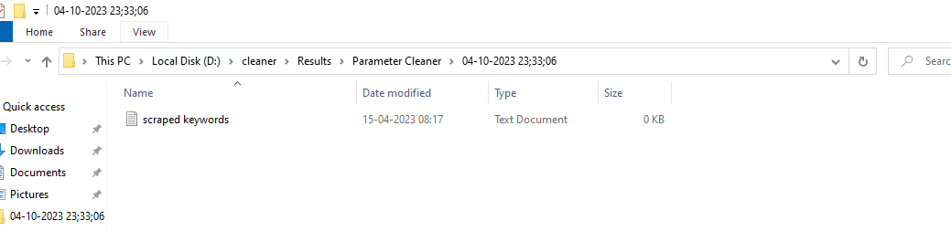

**I hope u would understand about the tool to make……**